

UNIVERSITY INSTITUTE OF ENGINEERING
Department of Computer Science & Engineering
(BE-CSE/IT-5th Sem)



Design and Analysis of Algorithms

Subject Code: 23CSH-301/ITH-301

Submitted to: Submitted by:
Mr. Rahul Bhandari Name: Mohd Shan
UID: 23BCS11520
Section: FS-634
Group: B

INDEX

Ex. No | List of Experiments | Date | Conduct (MM: 12) | Viva (MM: 10) | Worksheet (MM: 8) | Total (MM:30) | Remarks/Signature
1.1 | Analyze if stack Isempty, Isfull and if elements are present then return top element in stacks using templates and also perform push and pop  operation in stack.
1.2 | Develop a program for implementation of power function and determine that complexity should be  O(log n).
1.3 | Evaluate the complexity of the developed program  to find frequency of elements in a given array.
1.4 | - Apply the concept of Linked list and write code to Insert and Delete an element at the beginning and end of Singly Linked List.  - Apply the concept of Linked list and write code to Insert and Delete an element at the beginning and at end in Doubly and Circular Linked  List.
2.1 | Sort a given set of elements using the Quick sort method and determine the time required to sort the elements. Repeat the experiment for different values of n, the number of elements in the list to be

sorted. The elements can be read from a file or can be generated using the random number
generator.
2.2 | Develop a program and analyze complexity to implement subset-sum problem using Dynamic  Programming.
2.3 | Develop a program and analyze complexity to implement 0-1 Knapsack  using Dynamic Programming.
3.1 | Develop a program and analyze complexity to find shortest paths in a graph with positive edge weights using Dijkstra’s algorithm.
3.2 | Develop a program and analyze complexity to find all occurrences of a pattern P in a given string  S.
3.3 | Lab Based Mini Project.

Experiment No: 1

Student Name: MOHD SHAN UID: 23BCS11520
Branch: BE CSE Section/Group: 634-B
Semester: 5th Date of Performance: 16-07-2025
Subject Name: Design Algorithm and Analysis
SubjectCode: 23CSH301/ITH-301

Aim:

Analyze if stack Isempty, Isfull and if elements are present then return top element in stacks using templates and also perform push and pop
operation in stack.

Objective:

- To understand and implement a generic (template-based) stack.
- To check stack conditions like isEmpty() and isFull().
- To access the top element using peek() or top().
- To perform standard stack operations like push() and pop() using templates.
- To reinforce the concepts of object-oriented programming and templates in Java.

Procedure/Algorithm/Pseudocode:

Node:
data ← Integer
next ← Node

Stack:
top ← null

isEmpty():
If top = null then
return True
Else
return False

push(value):
Create newNode
newNode.data ← value
newNode.next ← top
top ← newNode

pop():
If isEmpty() then
Output "Stack Underflow"
return -1
Else
temp ← top.data
top ← top.next
return temp

peek():
If isEmpty() then
Output "Stack is Empty"
return -1
Else
return top.data

Main:
push(10)
push(20)
push(30)
Output "Top:", peek()
pop()
Output "Top after pop:", peek()
Output "Is Empty:", isEmpty()

Code:
public class StackUsingLL {

static class Node {
int data;
Node next;

Node(int data) {
this.data = data;
this.next = null;
}
}

static class Stack {
private Node top;

public Stack() {
top = null;
}

public boolean isEmpty() {
return top == null;
}

public void push(int value) {
Node newNode = new Node(value);
newNode.next = top;
top = newNode;
System.out.println("Pushed: " + value);
}

public int pop() {
if (isEmpty()) {
throw new RuntimeException("Stack is empty. Cannot pop.");
}
int value = top.data;
top = top.next;
System.out.println("Popped: " + value);
return value;
}

public int peek() {
if (isEmpty()) {
throw new RuntimeException("Stack is empty.");
}
return top.data;
}

public void displayTop() {
if (!isEmpty()) {
System.out.println("Top Element: " + peek());
} else {
System.out.println("Stack is empty.");
}
}
}

public static void main(String[] args) {
Stack stack = new Stack();

stack.push(10);
stack.push(20);
stack.push(30);

stack.displayTop();
stack.pop();
stack.displayTop();

System.out.println("Is Stack Empty? " + stack.isEmpty());
}
}
Observations/Outcome:

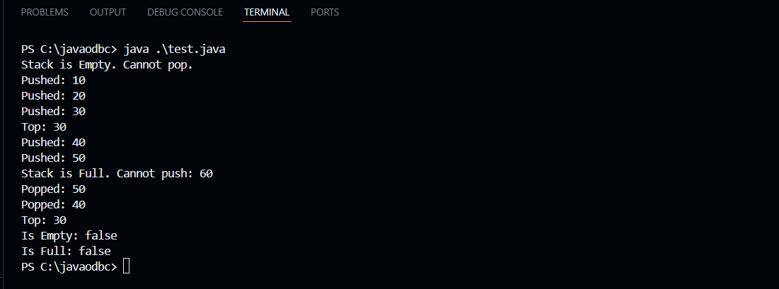

- Successfully implemented a generic stack in Java.
- Able to perform push, pop, peek, isEmpty, and isFull operations.
- The stack behaves correctly when full or empty.
- Proper output is shown for each operation.

Time Complexity:
- Push Operation: O(1)
- Pop Operation: O(1)
- Peek Operation: O(1)
- isEmpty/isFull: O(1)

Learning outcomes (What I have learnt):
- How to implement a generic (template-based) stack in Java using arrays.
- How to handle stack overflow and underflow conditions.
- How to use generics to make the stack reusable for different data types.
- How to define and use basic stack operations like push, pop, peek, isEmpty, and isFull.
- The difference in behavior between a full stack and an empty stack, and how to print meaningful error messages.

